**6 Ways to Look More Confident During a Presentation**

by

* [Kasia Wezowski](https://hbr.org/search?term=kasia%20wezowski)

April 06, 2017

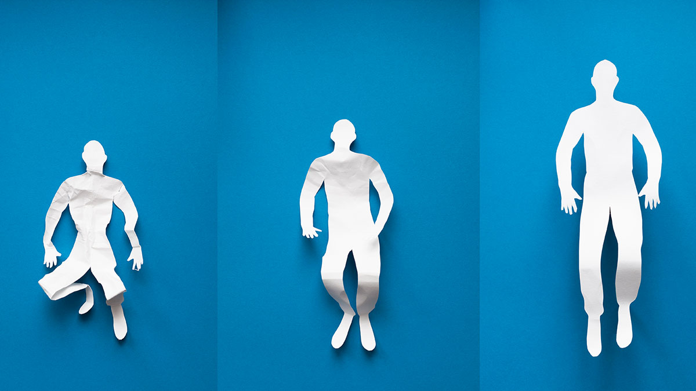

Several years ago, colleagues and I were invited to predict the results of a start-up pitch contest in Vienna, where 2,500 tech entrepreneurs were competing to win thousands of euros in funds. We observed the presentations, but rather than paying attention to the ideas the entrepreneurs were pitching, we were watching the body language and [microexpressions](https://hbr.org/2016/06/the-secret-to-negotiating-is-reading-peoples-faces) of the judges as they listened.

We gave[our prediction](https://www.youtube.com/watch?v=RUWSneGE5l4) of who would win before the winners were announced and, as we and the audience soon learned, we were spot on. We had spoiled the surprise.

Two years later we were invited back to the same event, but this time, instead of watching the judges, we observed the contestants. Our task was not to guess the winners, but to determine how presenters’ non-verbal communication contributed to their success or failure.

We evaluated each would-be entrepreneur on a scale from 0-15. People scored points for each sign of positive, confident body language, such as smiling, maintaining eye contact, and persuasive gesturing. They lost points for each negative signal, such as fidgeting, stiff hand movements, and averted eyes. We found that contestants whose pitches were rated in the top eight by competition judges scored an average of 8.3 on our 15-point scale, while those who did not place in that top tier had an average score of 5.5.Positive body language was strongly correlated with more successful outcomes.

We’ve found similar correlations in the political realm. During the 2012 U.S. Presidential election, we conducted an online study in which 1,000 participants—both Democrats and Republicans—watched two-minute video clips featuring Barack Obama and Mitt Romney at campaign events delivering both neutral and emotional content. Webcams recorded the viewers’ facial expressions, and our team analyzed them for six key emotions identified in psychology research: happy, surprised, afraid, disgusted, angry, and sad. We coded for the tenor of the emotion (positive or negative) and how strongly it seem to be expressed.  This analysis showed that Obama sparked stronger emotional responses and fewer negative ones. Even a significant number of Republicans—16%— reacted negatively to Romney. And when we analyzed the candidates’ body language, we found that the President’s resembled those of our pitch contest winners. He displayed primarily open, positive, confident positions congruent with his speech. Romney, by contrast, often gave out negative signals, diminishing his message with contradictory and distracting facial expressions and movement.

Of course, the election didn’t hinge on body language. Nor did the results of the start-up competition. But the right kinds of non-verbal communication did correlate with success.

How can you send out the same signals—and hopefully generate the same success? At the [Center for Body Language](http://centerforbodylanguage.com/), we’ve  studied successful leaders across a range of fields and identified several positions which are indicators of effective, persuasive body language.

**The box**

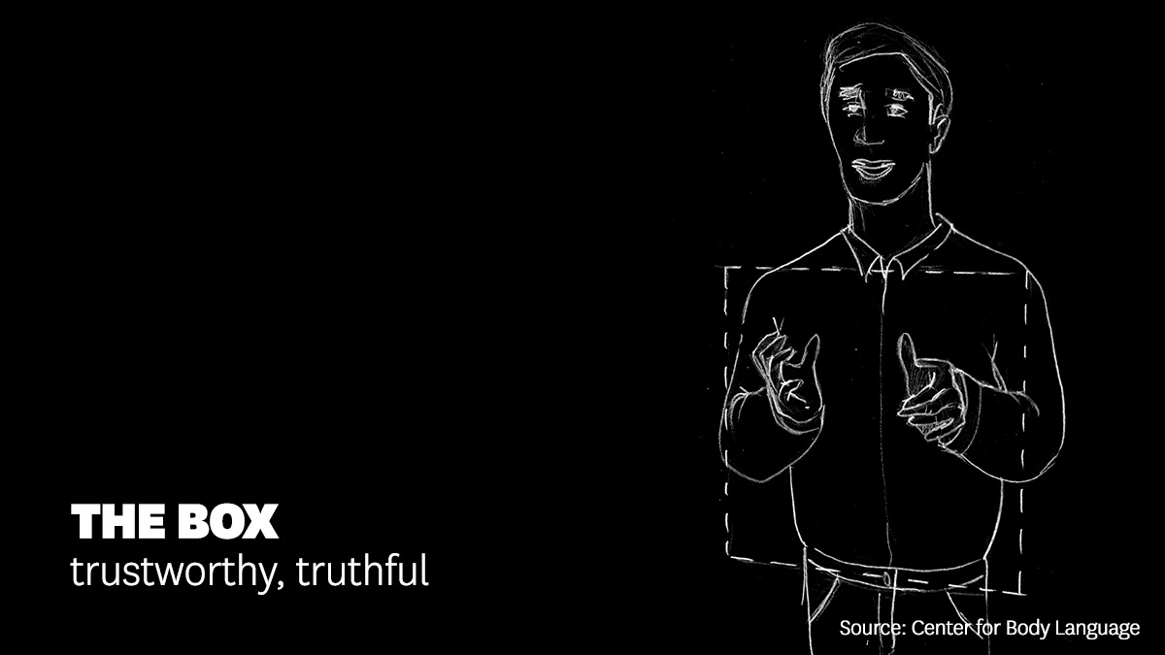

Early in Bill Clinton’s political career he would punctuate his speeches with big, wide gestures that made him appear untrustworthy. To help him keep his body language under control, his advisors taught him to imagine a box in front of his chest and belly and contain his hand movements within it. Since then, “the Clinton box” has become a popular term in the field.

**Holding the ball**

For HBR Subscribers

**How to Give a Great Presentation**

Tips to improve your talk, from preparation to delivery.

**Show Reading List**

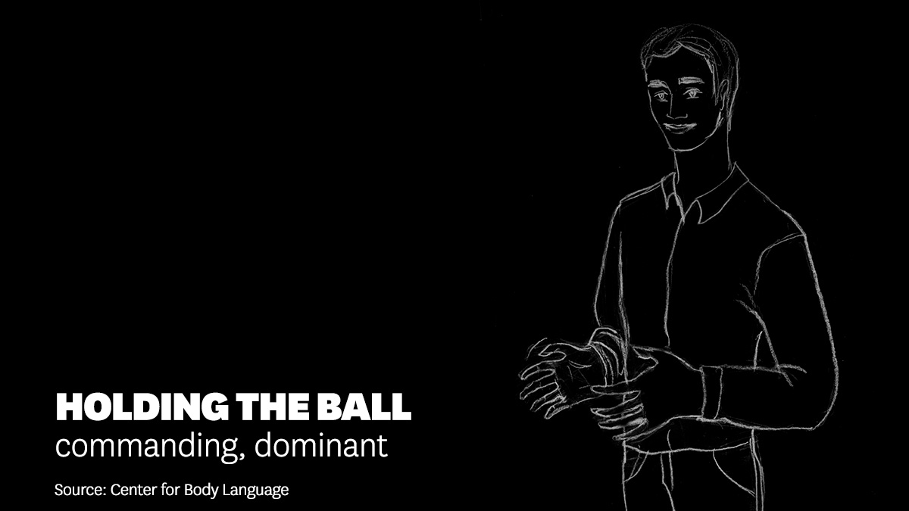

Gesturing as if you were holding a basketball between your hands is an indicator of confidence and control, as if you almost literally have the facts at your fingertips hands. Steve Jobs frequently used this position in his speeches.

**Pyramid hands**

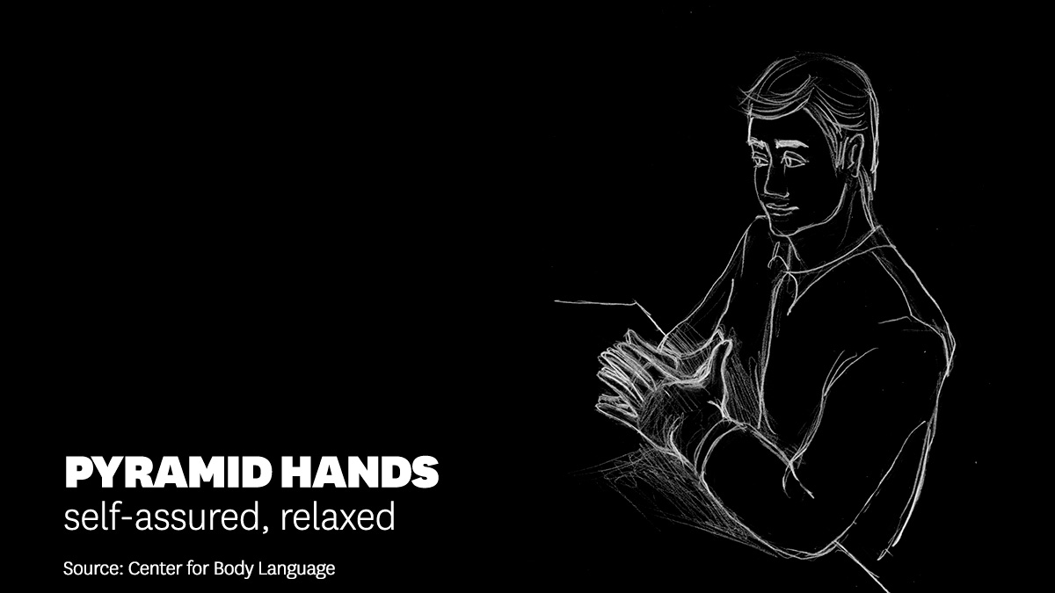

When people are nervous, their hands often flit about and fidget. When they’re confident, they are still. One way to accomplish that is to clasp both hands together in a relaxed pyramid. Many business executives employ this gesture, though beware of overuse or pairing it with domineering or arrogant facial expressions. The idea is to show you’re relaxed, not smug.

**Wide stance**

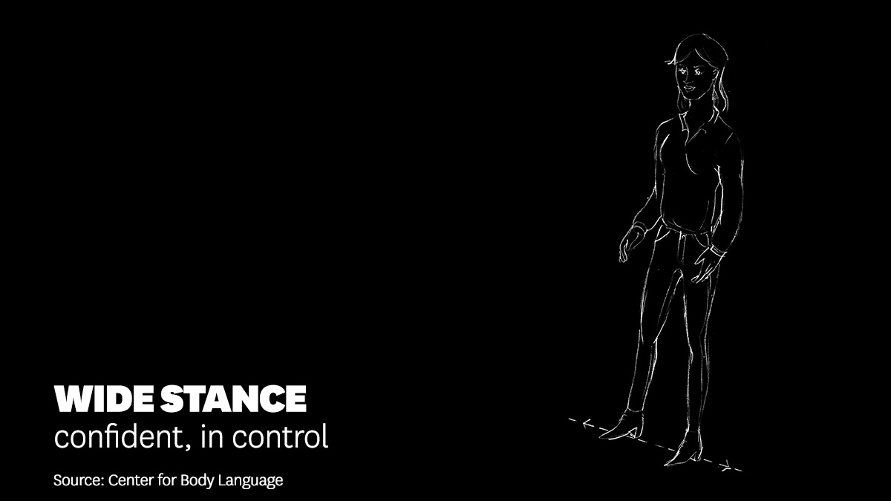

How people stand is a strong indicator of their mindset.  When you stand in this strong and steady position, with your feet about a shoulder width apart, it signals that you feel in control.

**Palms up**

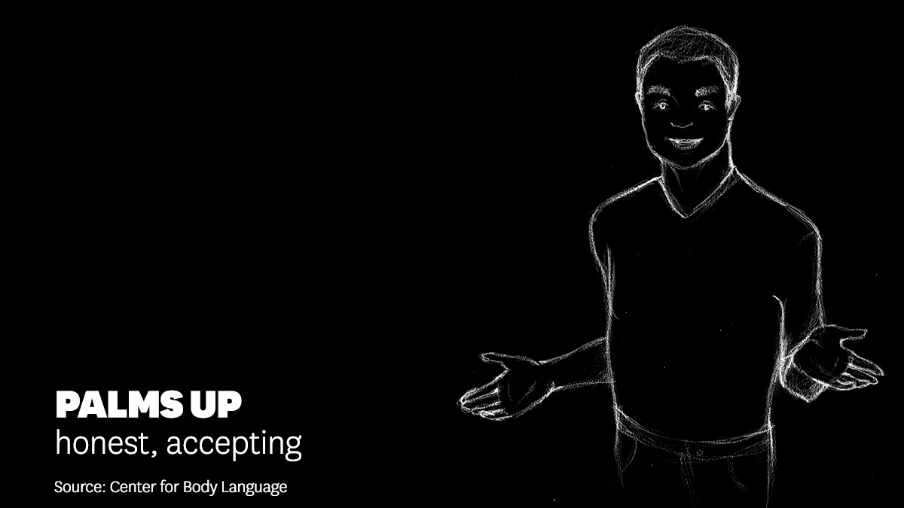

This gesture indicates openness and honesty.  Oprah makes strong use of this during her speeches. She is a powerful, influential figure, but also appears willing to connect sincerely with the people she is speaking to, be it one person or a crowd of thousands.

**Palms down**

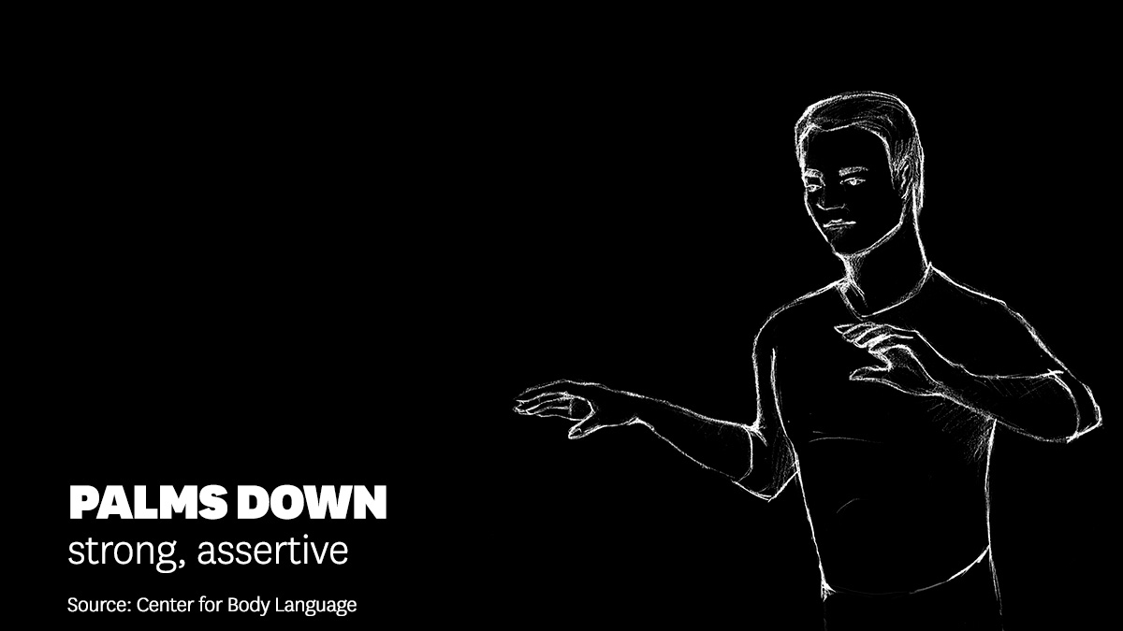

The opposite movement can be viewed positively too—as a sign of strength, authority and assertiveness. Barack Obama has often used it to calm a crowd right after moments of rousing oration.

The next time you give a presentation, try to have it recorded, then review the video with the sound off, watching only your body language. How did you stand and gesture? Did you use any of these positions?  If not, think about how you might do so the next time you’re in front of an audience, or even just speaking to your boss or a big client. Practice in front of a mirror, then with friends, until they feel natural.

**THIS ARTICLE ALSO APPEARS IN:**

Non-verbal communication won’t necessarily make or break you as a leader, but it might help you achieve more successful outcomes.